Date: ____________________
EXPERIMENT-2
IMPLEMENTATION OF STAR TOPOLOGY USING PACKET TRACER

Aim: To Implement a star topology using packet tracer and hence to transmit data between the devices connected using star topology.
Software / Apparatus required: Packet Tracer / End devices, bridge, connectors.
Steps for building topology:
Step 1: Start Packet Tracer
Step 2: Choosing Devices and Connections
Step 3: Building the Topology – Adding Hosts
Single click on the End Devices.
Single click on the Generic host.
Move the cursor into topology area.
Single click in the topology area and it copies the device.
Step 4: Building the Topology – Connecting the Hosts to Switches
Select a switch, by clicking once on Switches and once on a 2950-24 switch.
Add the switch by moving the plus sign “+”.
Step 5: Connect PCs to switch by first choosing Connections
Click once on the Copper Straight-through cable.
Click once on PC2.
Choose Fast Ethernet.
Drag the cursor to Switch0.
Click once on Switch0.
Notice the green link lights on PC Ethernet NIC and amber light Switch port. The switch port is temporarily not forwarding frames, while it goes through the stages for the Spanning Tree Protocol (STP) process. After about 30 seconds the amber light will change to green indicating that the port has entered the forwarding stage. Frames can now be forwarded out the switch port.
Step 6: Configuring IP Addresses and Subnet Masks on the Hosts
To start communication between the hosts IP Addresses and Subnet Masks had to be configured on the devices. Click once on PC0. Choose the Config tab and click on FastEthernet0. Type the IP address in its field. Click on the subnet mask; it will be generated automatically.
Step 7: To confirm Data transfer between the devices
Click on the node. Select desktop option and then command prompt. Once the window pops up, ping the IP address of the device to which node0 is connected. Ping statistics will be displayed.

Result: Thus the Star topology is implemented with Packet Tracer simulation Tool.
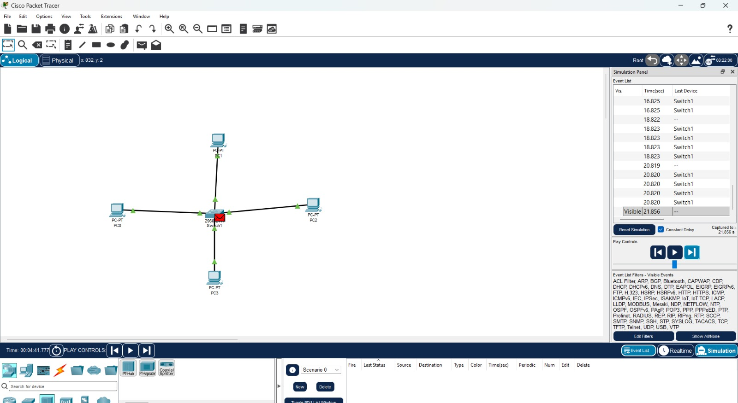
Date: ____________________
EXPERIMENT-3
IMPLEMENTATION OF BUS TOPOLOGY USING PACKET TRACER

Aim: To Implement a Bus topology using packet tracer and hence to transmit data between the devices connected using Bus topology.
Software / Apparatus required: Packet Tracer / End devices, Hubs, connectors.
Steps for building topology:
Step 1: Start Packet Tracer
Step 2: Choosing Devices and Connections
Step 3: Building the Topology – Adding Hosts
Single click on the End Devices.
Single click on the Generic host.
Move the cursor into topology area.
Single click in the topology area and it copies the device.
Step 4: Building the Topology – Connecting the Hosts to Switches
Select a switch, by clicking once on Switches and once on a 2950-24 switch.
Add the switch by moving the plus sign “+”.
Step 5: Connect PCs to switch by first choosing connections
Click once on the Copper Straight-through cable.
Click once on PC2.
Choose Fast Ethernet.
Drag the cursor to Switch0.
Click once on Switch0.
Notice the green link lights on PC Ethernet NIC and amber light Switch port. The switch port is temporarily not forwarding frames, while it goes through the stages for the Spanning Tree Protocol (STP) process. After about 30 seconds the amber light will change to green indicating that the port has entered the forwarding stage. Frames can now be forwarded out the switch port.
Step 6: Configuring IP Addresses and Subnet Masks on the Hosts
To start communication between the hosts IP Addresses and Subnet Masks had to be configured on the devices. Click once on PC0. Choose the Config tab and click on FastEthernet0. Type the IP address in its field. Click on the subnet mask; it will be generated automatically.
Step 7: To confirm Data transfer between the devices
Click on the node. Select desktop option and then command prompt. Once the window pops up, ping the IP address of the device to which node0 is connected. Ping statistics will be displayed.

Result: Thus the Bus topology is implemented with Pac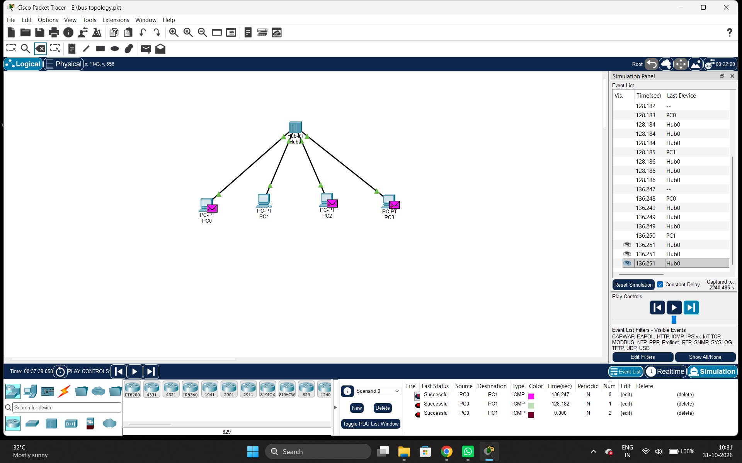ket Tracer simulation Tool.

